**Electrical Circuits Practice**

1. In the circuit below, what is the value of *R* if the reading on the ammeter is 0.04 A?

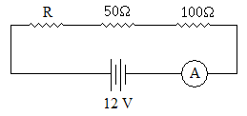

1. Find the value of *R* in the circuit below if the reading on the ammeter is 0.8 A.

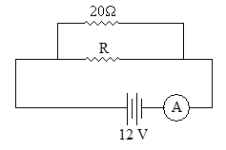

1. Find the readings on the voltmeter and ammeter in the circuit below.

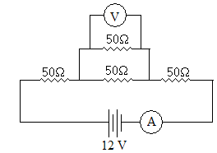

1. Find the reading on the ammeter in the circuit below.

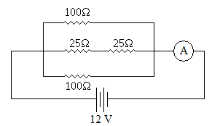

1. Find the readings on the voltmeter and ammeter in the circuit below.

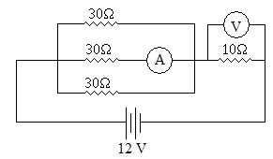

1. If the switch in the circuit below is opened, how will the brightness of the light be affected (if at all)? Explain why. (Hint: brightness is proportional to power.)

1. Find the readings on the voltmeter and ammeter in the circuit below.

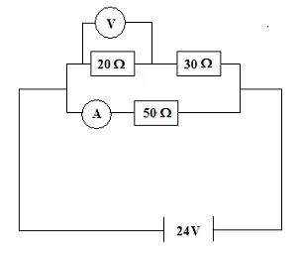

1. Three resistors with resistances of 20 Ω, 30 Ω, and 50 Ω are connected in series with a 12 V power supply. Calculate:
   1. the total resistance
   2. the current flowing in each resistor
   3. the potential difference across the 30 Ω resistor

The resistors are then connected in parallel. Find:

* 1. the total resistance
  2. the current through the 30 Ω resistor

1. An electrical engineer has set up the following circuit in an electrical device. Find the total resistance of the circuit and the readings on both meters.

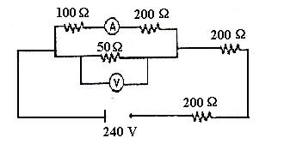

1. The following set of resistors is connected as shown:

* 1. What is the effective resistance between points A and B?
  2. If a potential difference of 24 volts was applied from A to B, what total current would flow through the circuit?
  3. What would the current through the 9 Ω resistor be while the 24-volt potential difference was being applied?
  4. Explain (without calculations) how you would rearrange the resistors above to create:
     1. the circuit with the maximum possible resistance
     2. the circuit with the minimum possible resistance

**Challenge Questions**

1. Work out the values reported by each ammeter and voltmeter in the circuit below.

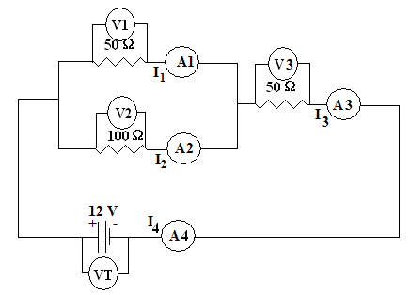

1. Work out the values reported by each ammeter and voltmeter in the circuit below.

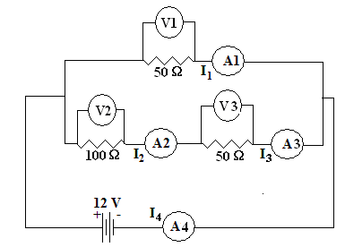

1. Work out the values reported by each ammeter and voltmeter in the circuit below.

